

Chetan P Murthy - PES2UG22EC042

Kiran S – PES2UG22EC069

Megha Y Rayana Goudra – PES2UG22EC077

**NAT ROUTER CONFIGURATION**

**Computer Communication Networks-Level 2 project**

**Problem statemen:**

Configure a network having 4 private networks (10.0.1.x, 10.0.2.x, 10.0.3.x, 10.04.x). The private networks should be able to communicate with a server having IP address 172.16.12.10 through a NAT enabled router.

**Network Diagram:**

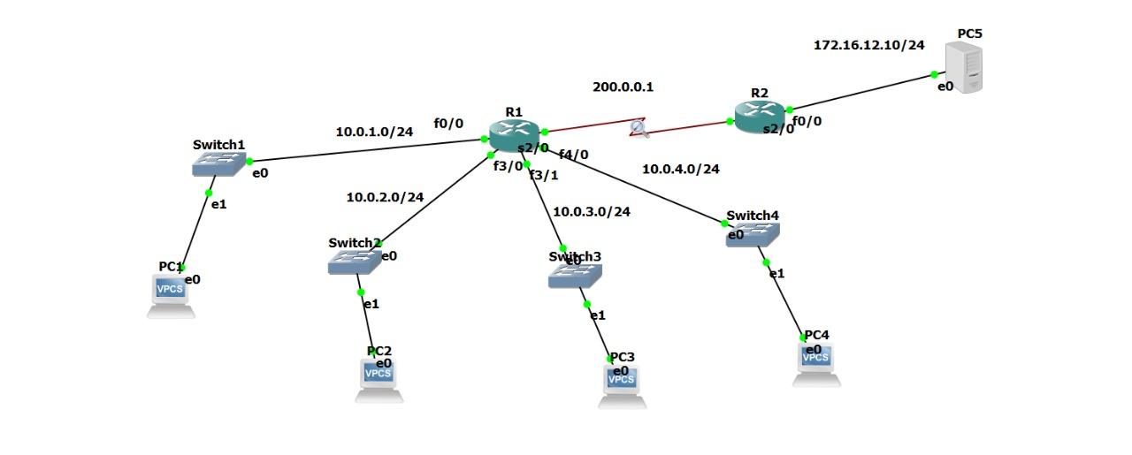

**Configuration Procedure:**

**R1:**

**R1(config)# interface f0/0**

**R1(config-if)# ip address 10.0.1.1 255.255.255.0**

**R1(config-if)# no shutdown**

**R1(config)# interface f3/0**

**R1(config-if)# ip address 10.0.2.1 255.255.255.0**

**R1(config-if)# no shutdown**

**R1(config)# interface f3/1**

**R1(config-if)# ip address 10.0.3.1 255.255.255.0**

**R1(config-if)# no shutdown**

**R1(config)# interface f4/0**

**R1(config-if)# ip address 10.0.4.1 255.255.255.0**

**R1(config-if)# no shutdown**

**R1(config)# interface s2/0**

**R1(config-if)# ip address 200.0.0.1 255.255.255.0**

**R1(config-if)# no shutdown**

**R1(config)#router rip**

**R1(config-router)# version 2**

**R1(config-router)# network 10.0.1.0**

**R1(config-router)# network 10.0.2.0**

**R1(config-router)# network 10.0.3.0**

**R1(config-router)# network 10.0.4.0**

**R1(config-router)# network 200.0.0.0**

**R1(config-router)# end**

**R1(config-if)# ip nat pool my_pub_ips 200.0.0.2 200.0.0.5 netmask 255.255.255.0**

**R1(config)# access-list 1 permit 10.0.1.0 0.0.0.255**

**R1(config)# access-list 1 permit 10.0.2.0 0.0.0.255**

**R1(config)# access-list 1 permit 10.0.3.0 0.0.0.255**

**R1(config)# access-list 1 permit 10.0.4.0 0.0.0.255**

**R1(config)# ip nat inside source list 1 pool my_pub_ips**

**R1(config)# ip nat log translations syslog**

**R1(config)# end**

**R1(config)# interface f0/0**

**R1(config-if)# ip nat inside**

**R1(config-if)# no shutdown**

**R1(config)# interface f3/0**

**R1(config-if)# ip nat inside**

**R1(config-if)# no shutdown**

**R1(config)# interface f3/1**

**R1(config-if)# ip nat inside**

**R1(config-if)# no shutdown**

**R1(config)# interface f4/0**

**R1(config-if)# ip nat inside**

**R1(config-if)# no shutdown**

**R1(config)# interface s2/0**

**R1(config-if)# ip nat outside**

**R1(config-if)# no shutdown**

**R1(config)# ip route 172.16.12.0 255.255.255.0 200.0.0.1**

**R2:**

**R2(config)# interface f0/0**

**R2(config-if)# ip address 172.16.12.1 255.255.255.0**

**R2(config-if)# no shutdown**

**R2(config)# interface s2/0**

**R2(config-if)# ip address 200.0.0.10 255.255.255.0**

**R2(config-if)# no shutdown**

**R2(config)# router rip**

**R2(config-router)# version 2**

**R2(config-router)# network 200.0.0.0**

**R2(config-router)# network 172.16.12.0**

**R2(config-router)# end**

**PC1: PC1> ip 10.0.1.2 10.0.1.1**

**PC2: PC2> ip 10.0.2.2 10.0.2.1**

**PC3: PC3> ip 10.0.3.2 10.03.1**

**PC4: PC4> ip 10.0.4.2 10.0.4.1**

**SERVER: Server> ip 172.16.12.10 255.255.255.0 172.16.12.1**

**Ping operation: PC1> ping 172.16.12.10**

**PC1:**

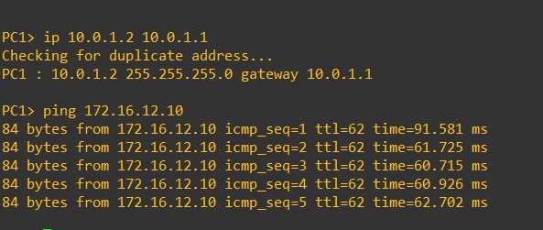

**PC1 ping:**

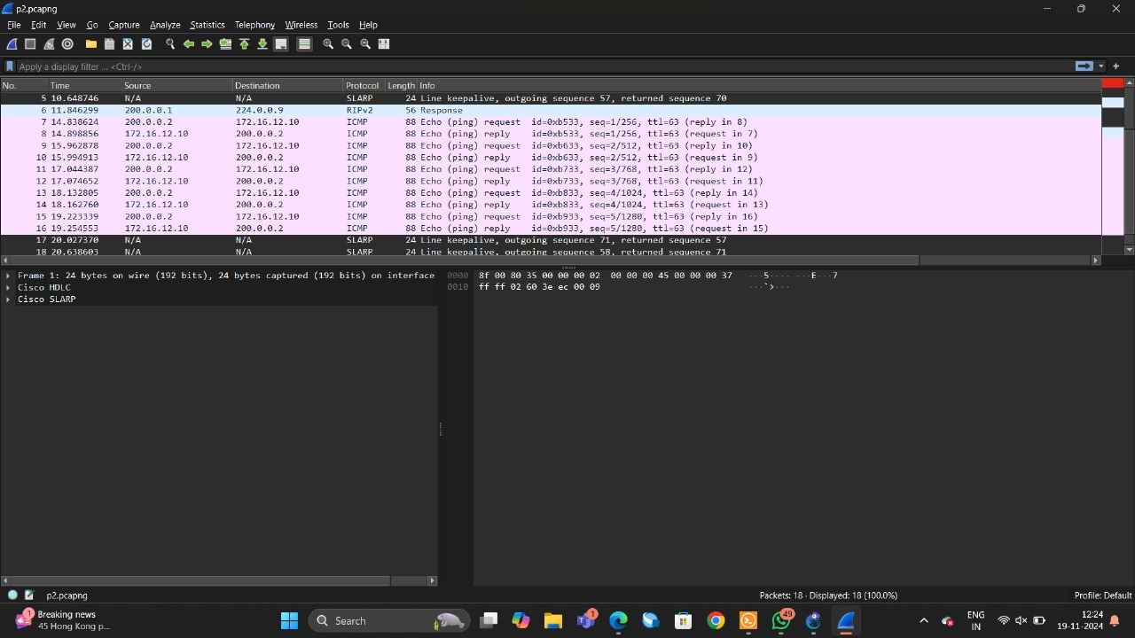

**Server:**

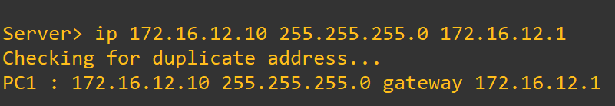

**Server1 ping:**



**R1 configuration:**

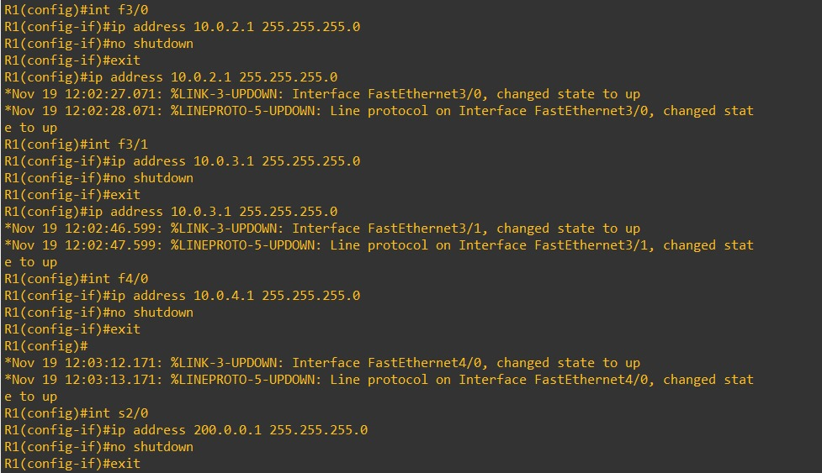

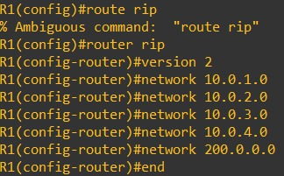

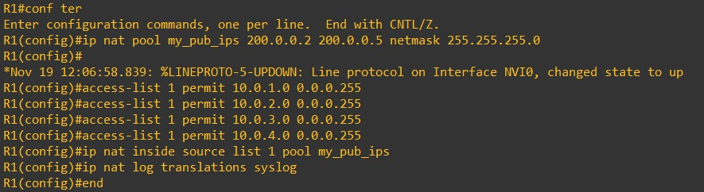

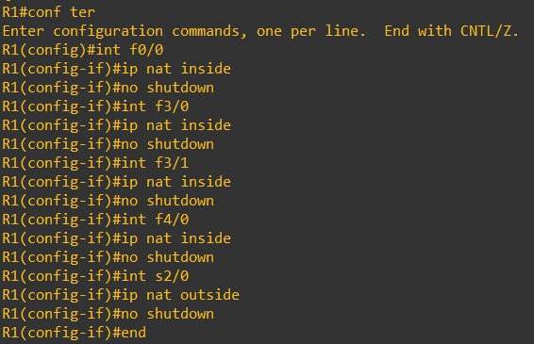

**R2 configuration:**

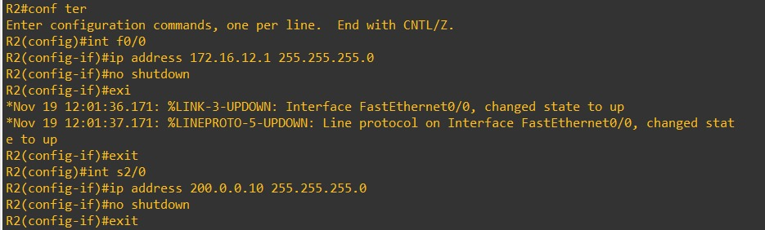

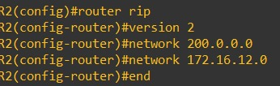

**Network Address Translation (NAT)**

**Network Address Translation (NAT)** is a technique used in computer networks to modify the IP address information in the header of IP packets while they are in transit across a routing device, typically a router or firewall. The primary purpose of NAT is to allow multiple devices on a local network (private network) to access external networks, like the internet, using a single public IP address.

**Types of NAT:**

1. **Static NAT:** This maps a single private IP address to a single public IP address. It is typically used for devices that need to be consistently accessed from the outside, like a web server.
2. **Dynamic NAT:** This maps a private IP address to a pool of public IP addresses. When a device sends traffic, a public IP address is temporarily assigned from the pool. Once the session ends, the public IP is released back into the pool.
3. **Port Address Translation (PAT) or Overloading:** This is the most common form of NAT used in home and office networks. It maps multiple private IP addresses to a single public IP address, using different ports to distinguish between sessions. This allows many devices within a private network to share one public IP address for internet access.

**Why NAT is Important:**

* **IP Address Conservation:** NAT helps conserve public IP addresses by allowing many devices to share a single public address.
* **Security:** NAT hides the internal network structure from the outside world, making it harder for external attackers to directly access internal devices.
* **Seamless Communication:** NAT enables private networks (using non-routable IP ranges) to communicate with public networks like the internet.

**Conclusion**

In this project, a network was effectively established to enable seamless communication between four private subnets (10.0.1.x, 10.0.2.x, 10.0.3.x, 10.0.4.x) and a public server with the IP address 172.16.12.10. A router configured with NAT (Network Address Translation) was deployed to ensure secure and efficient address translation, allowing the private networks to interact with the public network.

The setup involved assigning IP addresses correctly, configuring routing protocols, and implementing NAT functionality. Each device within the private subnets was able to reach the server via the NAT router, verifying that the configuration was correct. Connectivity was tested by performing ping operations between the clients and the server, which confirmed successful communication. Additionally, a packet capture conducted using Wireshark validated the translation and forwarding processes, demonstrating that the data flow was properly handled.

This implementation showcases the practical use of key networking principles, such as subnetting, NAT, and routing. The positive results from connectivity tests and traffic analysis indicate that the network design is both effective and reliable.